**My Lab Journal**

Contents

Lab #0 – Journal Example 3

Lab #1 – Basic Tasks 4

Lab #2 – Database Creation (Command Line) 5

Lab #3 – Control Files 6

Lab #4 – Redo Log Files and Archived Log Files 7

Lab #5 – Data Files (Storage) 8

Lab #6 – User Management 9

Lab #7 – Backup and Recovery (Basic Tasks) 10

Lab #8 – Backup and Recovery (Fix) 11

# Lab #0 – Journal Example

Start the database in *open* mode:

1. Check to see if databases are currently started on the server
   1. Open a terminal windows
   2. Type: lsnrctl status
   3. No databases currently started

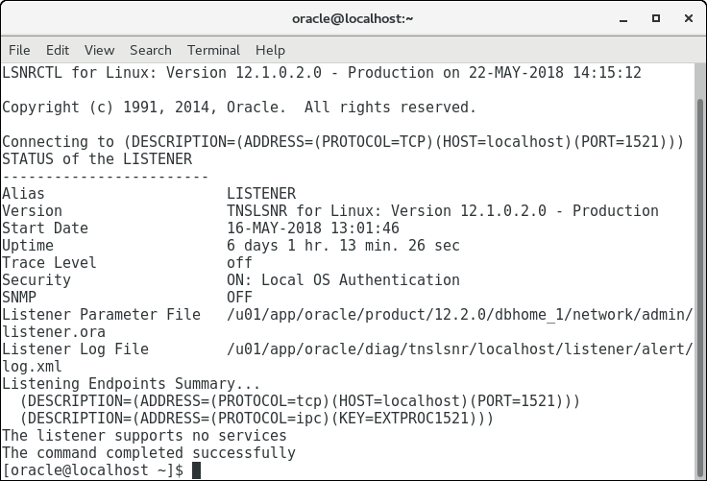

1. Open a terminal window
2. Type: export ORACLE_SID=FIRST
   1. This identifies the name of the database that will be used in this terminal window for Oracle utilities
3. Go into the SQL*Plus utility to start the database
   1. Type: sqlplus sys as sysdba
   2. Enter the password when prompted
4. Type: startup open
5. Database is now started and in an open state

# Lab #1 – Basic Tasks

# Lab #2 – Database Creation (Command Line)

# Lab #3 – Control Files

Adding control files

1. Shutdown db
2. Make a copy of the existing control file
3. Rename the copy with control file to the appropriate name
4. Update the Pfile to include the new control file in the control file list
5. Update SPFILE
   * Create spfile from
   * Pfile=’/u01/app/oracle/admion/{DB_name}/pfile/init{DB_NAME}.ora’
6. Start up and use it

Rename/moving control files

1. Shutdown db
2. Rename or moving the existeing control file
3. Update the PFILE to modify the name or path of the existing control file
4. Update the SPFILE
5. Start up and use it

Removing the control files

1. Shutdown
2. Remove the existing file
3. Update the PFILE to remove the reference to the delted control file in the control file in the control file list
4. Update the SPFILE
5. Start up and use it

Backup and control files

Alter database backup controlfile to trace;

Always select the script that has the noresetlogs option first.

Recovering control files

Replace it with a copy of a working control file.

If all of them files are missing or corrupted, one of the script that was generated when the control file was backed up to trace must be executed.

Running this script will create all control files based on the locations and names identified in the PFILE

Useful Data Dictionary Views

To view control file info

SELECT name

FROM v$controlfile;

To see the name of the database

SELECT name

FROM v$database;

To see the name and status of the database

SELECT name, open_mode

From v$database

# Lab #4 – Redo Log Files and Archived Log Files

# Lab #5 – Data Files (Storage)

# Lab #6 – User Management

# Lab #7 – Backup and Recovery (Basic Tasks)

# Lab #8 – Backup and Recovery (Fix)

CLASS Scenario – Journal Entry Example

1. Follow instructions on document to setup the database scenario
2. In SQL*Plus as SYS:
   1. Type: startup
3. The error displayed on the screen is:

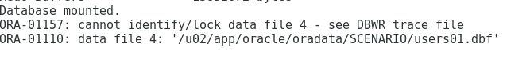

1. This error means that the RDBMS cannot find the users01.dbf file – the file is missing
2. To fix the database:
   1. Restore the users01.dbf file from the provided hot backup folder
   2. Type: ALTER DATABASE OPEN;
   3. New error:

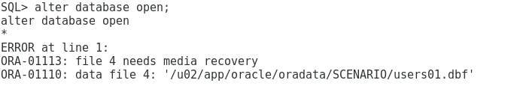

* 1. This error means that the backed up datafile was from an early point in time than the rest of the database so need to move it forward
  2. Type: recover datafile '/u02/app/oracle/oradata/SCENARIO/users01.dbf'
  3. Type: auto
     1. This is to apply all necessary archive log files
  4. Type: ALTER DATABASE OPEN;
  5. Database is successfully opened

1. As no data (transactional or user) was lost, this was a **complete** recovery